

BANK OF ISRAEL

Office of the Spokesperson and Economic Information

March 23, 2023

Press Release:

Debt Developments in the Nonfinancial Private Sector,

Fourth quarter of 2022

*For an analysis of debt developments in 2022 overall, see “*[*Nonfinancial private sector debt*](https://www.boi.org.il/publications/regularpublications/statistic_bulletin/bulletin2022/)*” in Part A of Statistical Bulletin for 2022 (translation forthcoming).*

The following is a summary of developments in nonfinancial private sector debt[1] in the fourth quarter of 2022:

* The balance of **business sector** debt increased by about 1.5 percent (NIS 18 billion) in the quarter, though the slowdown that began in the previous quarter in the balance’s rate of growth continued.
* The balance of **households’ debt** also continued to increase in the quarter, to approximately NIS 774 billion, though at a slower pace than in the previous quarter, at about 1.1 percent compared to 2.5 percent, against the background of a slowdown in the volume of new mortgages taken out by households from the banks.
* The source of the increase in the balance of households’ debt is the **balance of housing debt,** which increased by about NIS 9 billion (1.7 percent) this quarter, mostly to banks; the balance of **nonhousing debt** remained unchanged.

**The nonfinancial business sector’s outstanding debt[2]**

* In the fourth quarter of 2022, the **balance of business sector debt** continued to increase, by approximately NIS 18 billion (1.5 percent), to a level of about NIS 1.2 trillion. However, the slowdown in the balance’s growth rate, which began in the previous quarter, continued.
* The increase in the debt balance in the quarter derived mostly from net debt raised, and was focused on bank loans and tradable bonds in Israel. An increase of 0.8 percent in the CPI[3] also contributed to the increase in value of CPI-indexed debt; these effects were partly offset by net redemptions of nontradable bonds, a quantitative decrease in debt to abroad, as well as a 0.7 percent appreciation of the shekel vis-à-vis the dollar, which reduced the value of debt denominated in and indexed to foreign currency (Figures 1, 2).
* The annual growth rate of the balance of debt to banks and to nonbank lenders declined slightly this quarter, following a decline that began in the previous quarter, but it remains high—debt to banks grew by an annual rate of about 15 percent, compared to 20 percent in the preceding quarter, and debt to nonbank lenders by about 7 percent compared with 8 percent. In the past two years, the annual growth rate in the balance of debt to banks has been higher than the growth rate of debt to nonbank lenders.
* In the fourth quarter, the **business sector** **issued** about NIS 11 billion in bonds, lower than the average quarterly issuance of the past 4 quarters (about NIS 14 billion per quarter, on average). About half the issuances in this quarter were carried out by companies in the real estate and construction industry
* In January–February 2023, the business sector issued bonds worth an average of about NIS 5.3 billion per month, higher than the monthly average of issuances for 2022 (about NIS 4.5 billion in monthly average). Companies from the real estate and construction industry continued to lead issuance in these months as well—about 55 percent of total issues in those months were carried out by them (Figure 3).
* In the fourth quarter, **the spread[4] between yields on corporate bonds that are included in the Tel Bond 60 Index and the yields on CPI-indexed government bonds** widened by about 0.3 percentage points, to about 1.81 percentage points. However, in January–February 2023, the spread narrowed, to about 1.73 percentage points (Figure 4).

**Table 1: The Composition of Business Sector Debt**



**Figure 1: Estimated Net Quarterly Quantitative Change in Business Sector Debt**

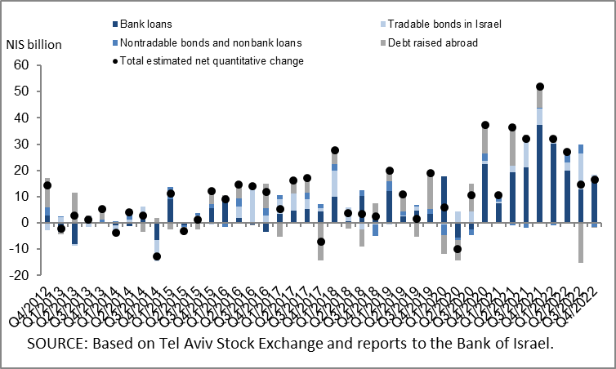

**Figure 2: Rate of Change (Year on Year) in the Business Sector's Bank and Nonbank Debt**

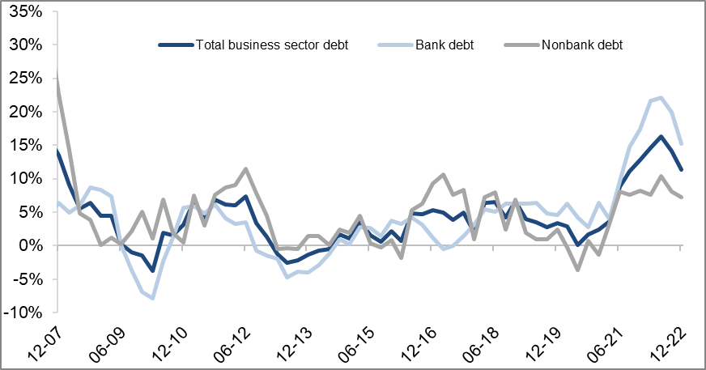

**Figure 3: Nonfinancial Business Sector Bond Issuance during the quarter, by Industry**

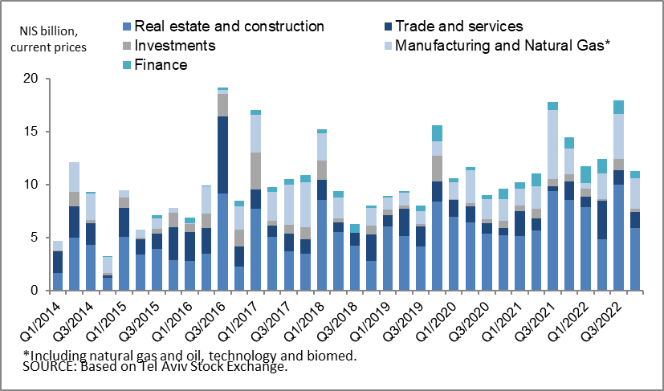

**Figure 4 : Spread between Indexed Corporate Bonds (Tel-Bond 60) and Indexed Government Bonds (monthly average)**

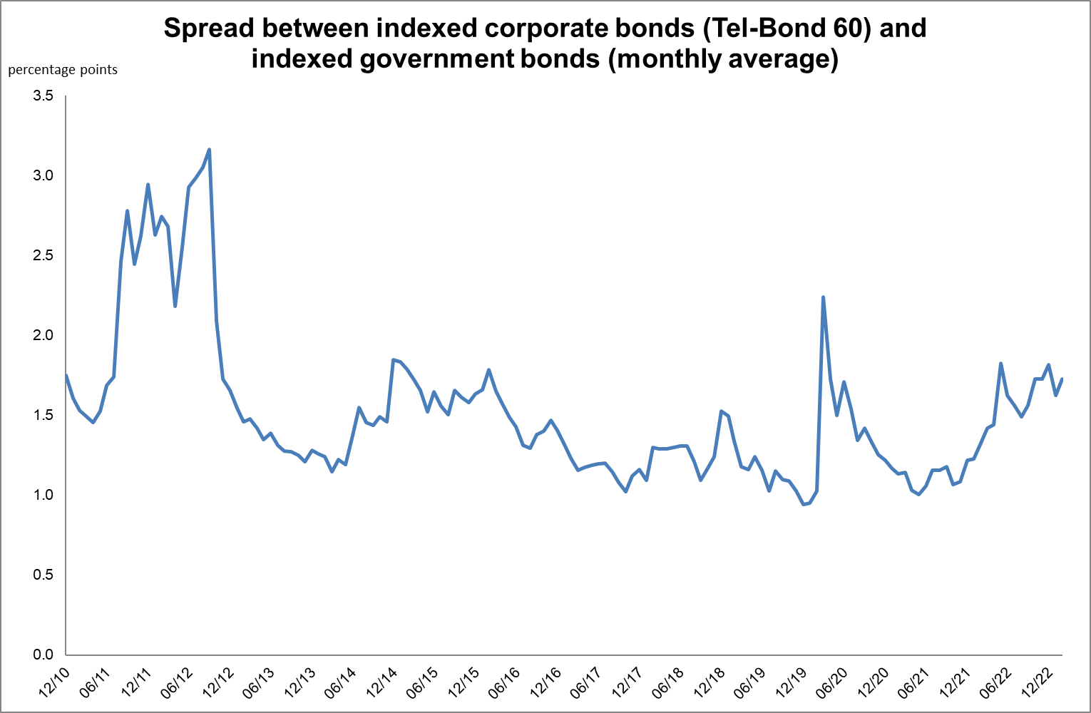

**Household debt**

* The growth in the **balance of households’ outstanding debt** continued in the fourth quarter of 2022, to NIS 774 billion, (an increase of about NIS 9 billion, 1.1 percent). However, the slowing in its rate of growth continued in the quarter, about 1.1 percent compared to 2.5 percent in the previous quarter.

The marked increase in outstanding **housing debt** continued (about NIS 9 billion; 1.7 percent), mostly to banks, and **nonhousing debt** remained unchanged in this quarter, at NIS 232 billion, as a result of an increase in the balance of debt to banks and credit card companies (an increase of about NIS 1 billion to each of them), which was offset by a decline in the balance of debt to institutional investors (Figure 5).

* In the fourth quarter of 2022, new mortgages taken out totaled about NIS 21 billion, lower than in the corresponding quarter of the previous year (about NIS 34 billion). The decline in new mortgages taken out that began in May 2022 continued, and in January-February 2023, they totaled about NIS 12 billion (Figure 6).

**Table 2: Outstanding Debt Balances of Households1**



**Figure 5: Rates of Change in Households’ Housing and Nonhousing Debt, Current Quarter vs. Corresponding Quarter of Previous Year**

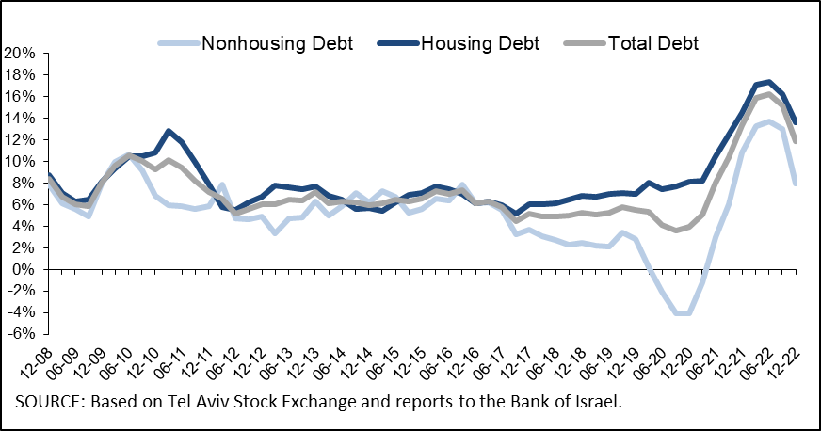

**Figure 6: Amount of New Home Purchase Loans Provided by Banks to the Public (Mortgages)**

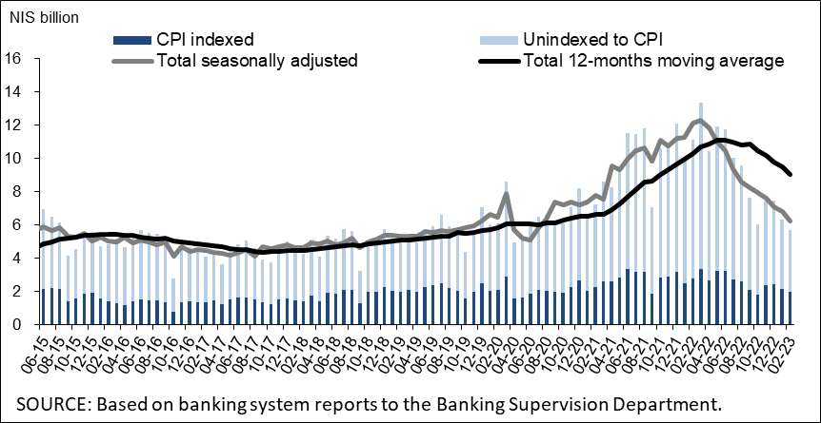

Links to Data and Statistics on the Bank of Israel website:

<https://www.boi.org.il/en/economic-roles/data-and-statistics/money-and-debt-aggregates/debt-and-credit/>

1. Data on debt to banks are based on monthly balance sheet data and not on annual financial statements, because as of the writing of this notice, financial statement data for 2022 have not yet been published.
2. Israeli firms, excluding banks, credit card companies, and insurance companies.
3. CPI-indexed balances are calculated based on the CPI reading known at the time the financial statements are compiled, so that a change in the CPI refers to the change between the known CPI and the CPI in the month before that one.
4. The change in the spread from one quarter to the next is calculated as the difference between the average spread in the final month of the reviewed quarter and the average spread in the final month of the previous quarter.