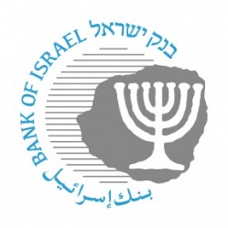

**BANK OF ISRAEL**

Office of the Spokesperson and Economic Information

May 7, 2024

Press Release:

Foreign Exchange Reserves at the Bank of Israel, April 2024

Israel’s foreign exchange reserves at the end of April 2024 stood at $208,109 million, a decrease of $5,632 million from their level at the end of the previous month. The level of the reserves relative to GDP was 41 percent (Figure 1).

The decline was mainly the result of a revaluation[1] that decreased the reserves by approximately $3,895 million and the government’s foreign exchange activities totaling approximately $1,703 million.

**Israel's Foreign Exchange Reserves** ($ million)

|  |  |  |  |
| --- | --- | --- | --- |
| **Date** | **Reserves excluding IMF (including reserves bought under the natural gas purchase program)** | **Reserves at the IMF[2]** | **Total Foreign Exchange Reserves** |
| April 2024 | 203,656 | 4,453 | 208,109 |
| March 2024 | 209,261c | 4,480 | 213,741c |
| February 2024 | 202,326c | 4,495 | 206,821c |
| January 2024 | 201,597 | 4,528 | 206,125 |
| December 2023 | 200,090c | 4,604c | 204,694c |
| November 2023 | 193,590 | 4,579 | 198,169 |
| October 2023 | 186,675 | 4,560 | 191,235 |
| September 2023 | 194,025 | 4,528c | 198,553c |
| August 2023 | 198,338 | 4,518 | 202,856 |
| July 2023 | 200,086c | 4,579 | 204,665c |
| June 2023 | 197,363c | 4,513 | 201,876c |
| May 2023 | 195,100 | 4,521 | 199,621 |
| April 2023 | 197,390 | 4,505 | 201,895 |

**Figure 1**

**Level of foreign exchange reserves, and their ratio to GDP, 2007–2024**

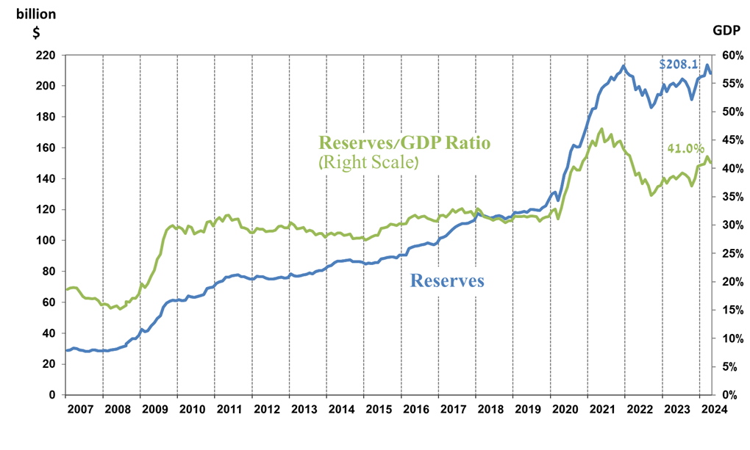

1. a Includes Bank of Israel payments and receipts in foreign currency.
2. b This column includes Special Drawing Rights (SDRs), the balance of NAB loans, and the balance of Israel's reserve tranche at the IMF.

   c Updated after the original date of publication.