

BANK OF ISRAEL

Office of the Spokesperson and Economic Information

June 27, 2021

Press Release

Israel’s International Investment Position (IIP),

First Quarter of 2021

* **In the first quarter of 2021, the balance of assets held abroad by Israeli residents increased by approximately $27 billion (4 percent), to about $627 billion at the end of March. The increase derived mainly from an increase in the foreign securities portfolio as a result of net investment in equities and growth in reserve assets.**
* **Outstanding liabilities to abroad increased by approximately $25 billion (6 percent) in the first quarter, to about $436 billion at the end of the quarter. The increase derived primarily from growth in the value of the portfolio of Israeli securities held by nonresidents as a result of net investment in bonds and net direct investment.**
* **Israel’s surplus of assets over liabilities vis-à-vis abroad in the first quarter increased by approximately $1.5 billion (0.8 percent), to about $191 billion at the end of March.**
* **The surplus of assets over liabilities vis-à-vis abroad in debt instruments alone (negative net external debt) decreased by $4.5 billion (2 percent) during the first quarter, to approximately $198 billion at the end of March.**
* **The ratio of gross external debt to GDP increased by an anomalous rate of 2.5 percentage points during the course of the first quarter, to 35 percent at the end of March. The increase in the debt to GDP ratio reflected an increase of 10 percent in the balance of external debt (mainly investments by nonresidents in nominal bonds) and an increase of only 2 percent in GDP (in dollar terms).**

Table 1: Asset and liability balances, and changes in them

A table detailing the balance of Israel’s assets and liabilities vis-à-vis abroad, and the changes in those categories.  The table can be found in the Excel file attached to this notice in the “Table” worksheet.

Source: Bank of Israel data and compilations i

1. **The balance of Israel’s assets abroad**

In the first quarter of 2021, the assets held abroad by Israeli residents increased by about $27 billion (4 percent) to about $627 billion at the end of March.

The increase in the balance derived mainly from an increase in the value of the foreign securities portfolio and growth in reserve assets.

* **The value of direct investments** in the first quarter remained similar to that of the previous quarter, mainly as a result of an increase in owners’ loans that was nearly fully offset by a decrease in direct investment in share capital.
* **The value of the securities portfolio** increased during the first quarter by about $12 billion (6 percent) mainly as a result of increases in prices of foreign securities by approximately $7 billion (3 percent of the balance of financial investments). This follows the price increases in the previous quarter and is in line with the increases in equity indices worldwide.

In addition, the increase in the portfolio value was contributed to by $10 billion in net investment in equities, which was slightly offset by realizations of about $3.5 billion in foreign tradable bonds. Most of the investments in equities were by institutional investors (about $7 billion) (Figure 1).

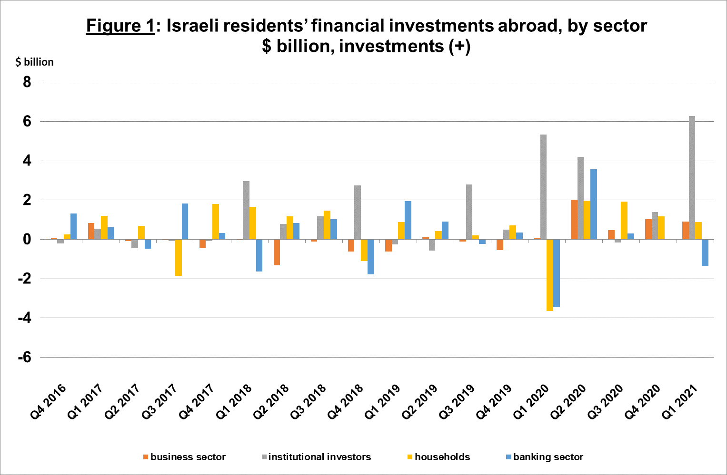

Source: Bank of Israel data and compilations [1]

* **The value of other investments** abroad increased by about $2 billion (2 percent) in the first quarter, mainly due to net investments in other assets of about $2 billion, mostly investments by institutional investors in foreign investment funds.
* **The value of the foreign exchange reserves** increased during the first quarter by about $12 billion (7 percent), to about $186 billion at the end of March. The increase derived from Bank of Israel foreign exchange purchases totaling $14 billion, which were partly offset by a revaluation that totaled $2 billion.
* **The composition of Israelis’ securities portfolio abroad**: At the end of the first quarter, there was an increase of about 1 percentage point in the share of Israeli residents’ equity instruments abroad, to about 46 percent, and a decline in the share of debt instruments to a level of 54 percent.

1. **Israel’s liabilities to abroad**

The balance of Israel's liabilities to abroad increased by about $25 billion (6 percent) in the first quarter, to about $436 billion at the end of March. The increase derived from $18 billion in net investments by nonresidents in tradable securities and by net direct investment of $7 billion.

* **The value of direct investments in the economy** increased during the first quarter by $8 billion (4.5 percent). The increase derived mainly from direct investments in Israeli equities of approximately $7 billion, dispersed over a large number of companies, including approximately $1.4 billion in respect of profits that accrued for investment.
* **The value of the securities portfolio** increased by $17 billion (10 percent) during the first quarter, primarily as a result of net investment in bonds totaling $15 billion, most of it in short term nominal government bonds, totaling $8 billion, and in makam totaling $4 billion.
* **The value of nonresidents' financial portfolio on the Tel Aviv Stock Exchange[2],** which makes up a part of nonresidents’ investments in Israel, increased by about $14 billion in the first quarter, to about $70 billion at the end of March. The change in the value of the portfolio was due mainly to net investment in bonds, particularly short term nominal government bonds and in makam, totaling $15 billion, a relatively high investment relative to the scope of investment in previous quarters (Figure 2 and Figure 3).

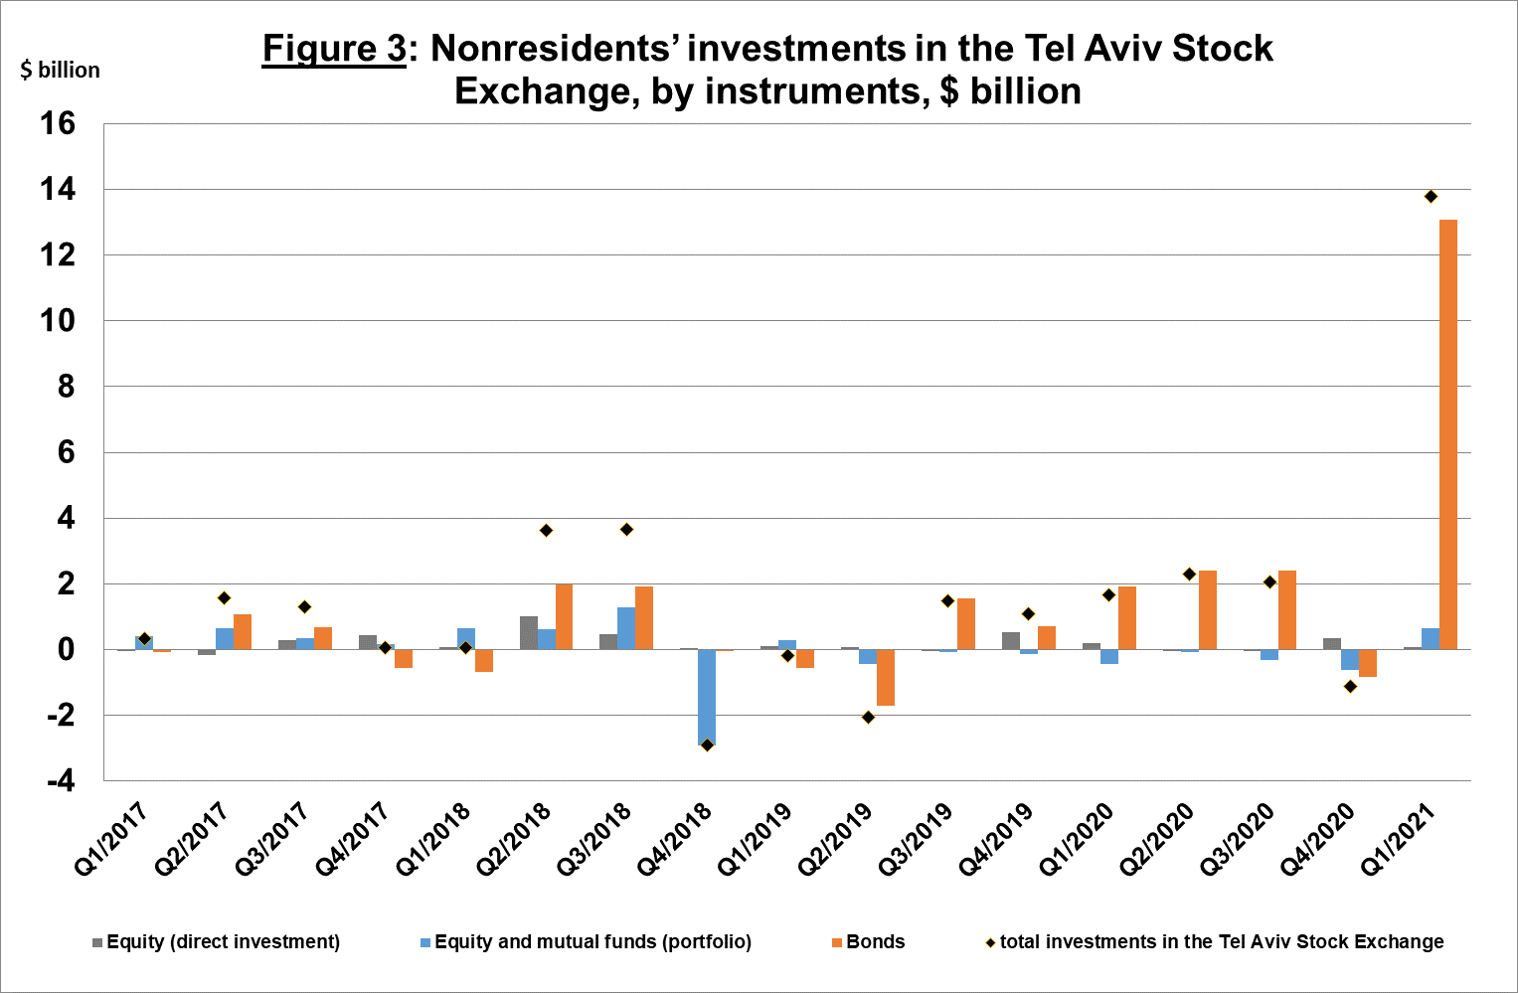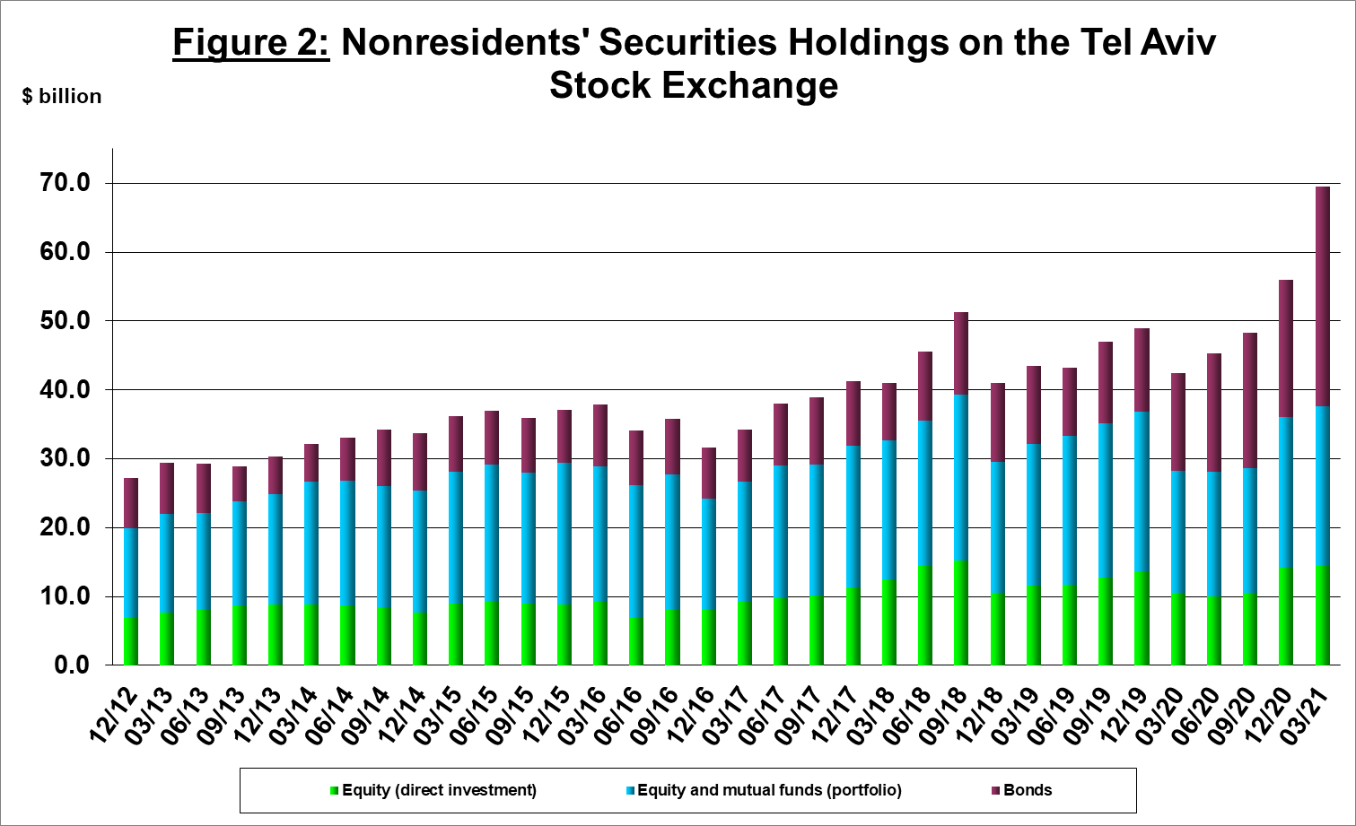

Source: Israel Securities Authority, Bank of Israel data and compilations i

**The value of other investments in the economy remained similar to that of the previous quarter,** mainly as a result of growth of about $0.6 billion in suppliers’ credit which was fully offset by a similar amount in net withdrawals from deposits of nonresidents and foreign banks.

**The balance of liabilities in debt instruments alone,** which makes up **Israel's gross external debt,** increased by about $13 billion (10 percent) in the first quarter, to $143 billion, mainly as a result of net investment in bonds.

**The ratio of gross external debt to GDP** increased by an anomalous 2.5 percentage points in the first quarter, to 35 percent at the end of March. The increase in the debt to GDP ratio reflected an increase of 10 percent in the balance of gross external debt as opposed to an increase of only 2 percent in GDP (in dollar terms) (Figure 4).

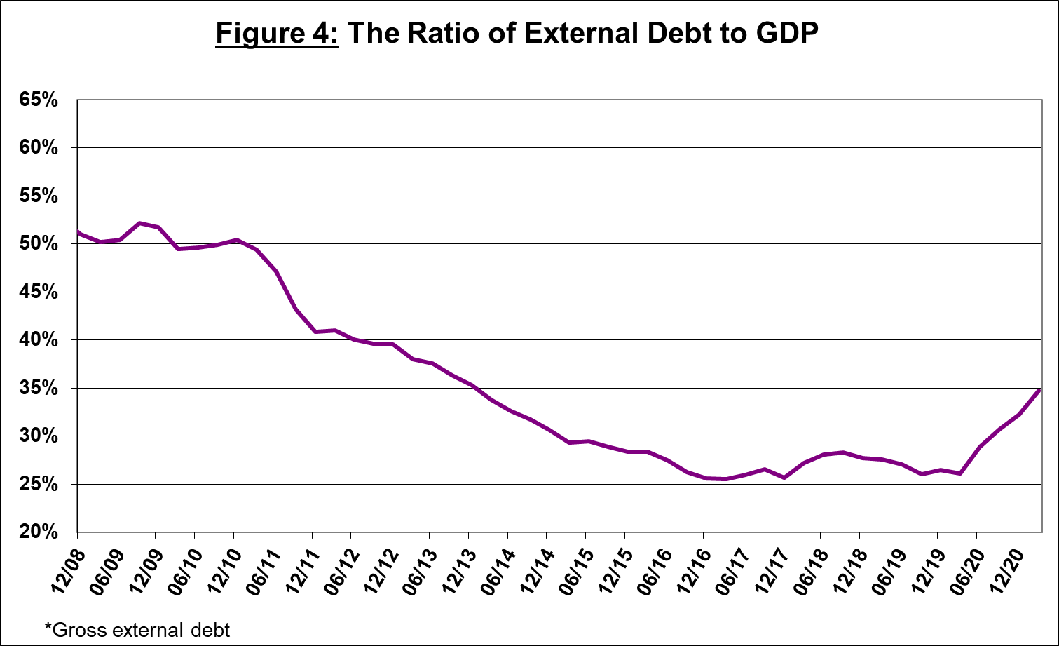

Source: Ministry of Treasury, Israel's Central Bureau of Statistics, Bank of Israel data and compilations i

1. **Israel’s surplus assets over liabilities vis-à-vis abroad**

An increase in outstanding assets that was greater than an increase in outstanding liabilities led to an increase of $1.5 billion (0.8 percent) in surplus assets over liabilities vis-à-vis abroad, which totaled about $191 billion at the end of March (Figure 5).

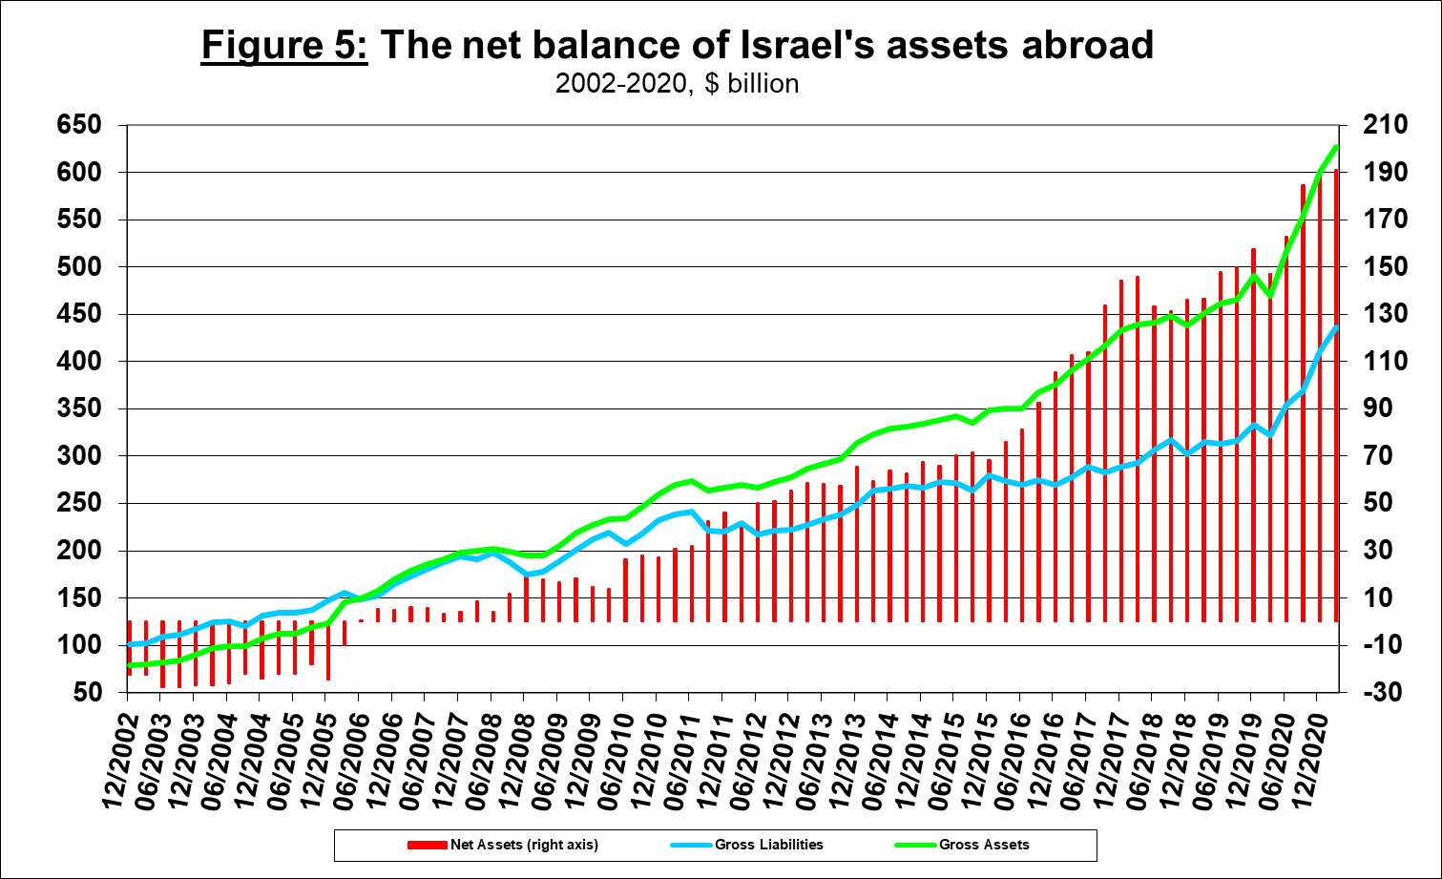

Source: Bank of Israel data and compilations i

1. **Net external debt**

The surplus of assets over liabilities vis-à-vis abroad in debt instruments alone (negative net external debt) decreased by $5 billion (2 percent) during the first quarter, to $198 billion at the end of March (Figure 6).

**The balance of short-term debt assets** (maturity/realization within a year) increased in the first quarter by $9 billion, to $341 billion at the end of the quarter, of which $186 billion is the Bank of Israel's foreign exchange reserves. This reflects a coverage ratio of 4.8 times short-term debt.

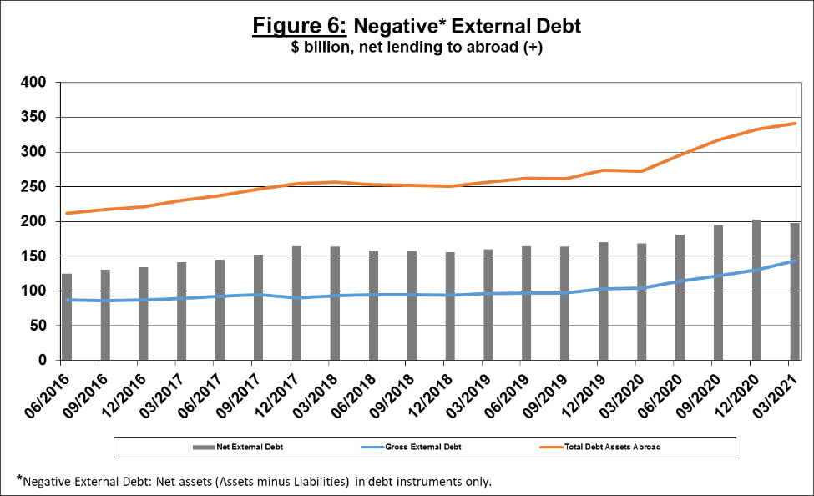

Source: Ministry of Treasury, Bank of Israel data and compilations i

[For the complete data file, click here](https://www.boi.org.il/he/NewsAndPublications/PressReleases/Pages/25-3-21.aspx?fireglass_rsn=true).

1. Bank of Israel data and compilations:The Bank of Israel Information and Statistics Department manages a database of economic activity vis-à-vis abroad. The Department gathers data and information from various sources. Most of the data are received r by companies and individuals to the Bank of Israel pursuant to the Bank of Israel Orde from direct reports (see “Information on the Development of the Foreign Exchange Market in Israel, 5770–2010). Additional data used to measure economic activity vis-à-vis abroad are obtained from reports by the institutional investors, the Bank of Israel Accounting Division, the Israel Securities Authority, the Ministry of Finance, Israel’s Central Bureau of Statistics and domestic banks. The Information and Statistics Department processes the data obtained from the various sources.
2. <https://www.boi.org.il/en/NewsAndPublications/PressReleases/Pages/25-3-21.aspx>