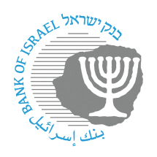
BANK OF ISRAEL

November 19, 2023

Call for public consultation –
The identification code used by banking corporations and nonbank entities to connect to the payment systems

The public and relevant financial entities who make use of identification codes are invited to respond to questions and to provide other relevant information to the Bank of Israel regarding the expansion that is expected to be completed on January 1, 2027. A notice on how the identification codes will be expanded will be published in July 2024.

November 2023
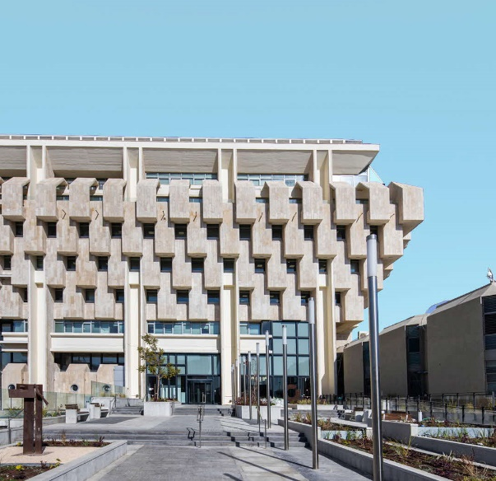
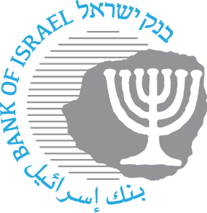

Every bank and financial entity is currently identified in the payment systems and peripheral systems using a two-digit identification code. In the past, this was known as a “bank code”, but in view of the multiplicity of nonbank entities requesting to participate in the payment systems, the Bank of Israel changed the name to “identification code”. The two-digit format of the code limits the number of participants in the financial systems to 99. As part of a series of measures intended to increase competition in the Israeli economy, and in order to encourage more entities to join, it is necessary to expand the identification codes that currently exist. Th expansion will be to a larger number of digits, which will provide a response for needs to connect to the payment systems in the coming years, and will enable an increase in the number of financial participants.

The Bank of Israel invites the public and relevant financial institutions who use identification codes to send in positions and responses to the questions in this document, as well as additional information regarding the expected expansion.

A notice on how the identifications codes will be expanded will be published in July 2024.

In order to formulate an optimal solution and decision on how to expand the identification codes, we would appreciate your responses to the following questions, as well as other relevant information that can contribute to the decision-making process.

- In what systems and interfaces do you use an identification code?
- How many characters exist for the identification code in each of the organization’s systems that were mentioned?
- The expansion options of which we are currently aware are increasing the number of characters (to between 3 and 12 characters), a move to an alphanumeric structure, use of an IBAN number, and use of the branch field (while removing this field from the account identification). What type of expansion is optimal from your point of view?
- Do you have other suggestions for the expansion?
- From your point of view, does expansion of the number of characters (to between 3 and 12 characters) affect the complexity of the solution and how it is implemented?
- What is your estimate of the resources that will be necessary to make the expansion (increase in the number of characters) within the planned timeframe (ending in December 2026)?
- Does the decision on the format of the expansion (between 3 and 12 characters) affect the amount of resources necessary? If yes, please describe the differences?
- Would you be interested in participating in the team entrusted with the expansion program? If yes, please provide complete details of a contact person (full name, mobile number, position, email address).

The public is invited to respond to this call for consultation, and to contact us at bank.kod@boi.org.il with any questions or points of clarification.

Please note the following details: Name and position of the person making the enquiry, organization name, and email address. Responses will be accepted until January 31, 2024.

