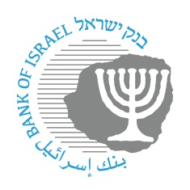
BANK OF ISRAEL
Office of the Spokesperson and Economic Information

November 19, 2023

Press Release:

Allocation of Identification Codes to Nonbank Payment Service Providers

Meshulam Payment Solutions Ltd., Global Remit-Currency Services Ltd., and A.T.M.S Matrix Ltd.

Participants in Israel’s financial system are identified by a 2-digit identification code (known today as a “bank code”) that is unique to each entity. The Bank of Israel announces for the first time the allocation of identification codes to fintech companies that are in the process of connecting to the payment system in Israel.

This step is in line with other steps taken by the Bank of Israel to open access to nonbank entities and to promote competition in the payments market, so that fintechs will be able to act directly and independently in the controlled payment systems in Israel, while reducing the dependence on banks. Together with appropriate licensing from the relevant regulator, the bank code will enable fintechs to be identified uniquely by other participants in the payment system, and will enable them to assign a payment account number to their customers. Following are the identification codes that were allocated:

- The identification code allocated to Meshulam Payment Solutions Ltd. (known also as Grow by Meshulam) is 35.

- The identification code allocated to Global Remit-Currency Services Ltd. is 47.

- The identification code allocated to A.T.M.S Matrix Ltd. is 86.

Payment and Settlement Systems Department Director Mr. Oded Salomy: “Even in complex times, such as those in which the State of Israel is situated, it is important to connect nonbank entities to the payment systems. Some of these entities recently assisted in transferring funds from abroad to nonprofit organizations in Israel that are helping victims of the terrorism or displaced families. The new entities will contribute to enhancing the financial stability by promoting competition and assisting in reducing the concentration in the market, will develop innovative and advanced solutions, will increase the efficiency of business processes and services, and will reduce costs for the benefit of consumers and businesses in Israel.”

