

BANK OF ISRAEL

Office of the Spokesperson and Economic Information

September 25, 2024

Press Release:

# The public's financial assets portfolio in the second quarter of 2024

* **In the second quarter of 2024, the balance of the public’s financial assets portfolio increased by approximately NIS 65 billion (1.15 percent), to about NIS 5.75 trillion.**
* **The increase in the portfolio’s value in the second quarter was mainly due to increases in the balance of investments abroad (6.1 percent), and in the balance of government bonds and *Makam* (3.5 percent). In contrast, there were declines in the balance of equities in Israel (8.5 percent), and in the balance of corporate bonds (2.1 percent).**
* **The balance of the asset portfolio managed by institutional investors increased in the second quarter by approximately NIS 41 billion (1.6 percent), to NIS 2.66 trillion at the end of the quarter.**
* **Institutional investors’ rate of exposure to foreign assets and to foreign currency increased by about 2.3 percentage points and by 1 percentage point, respectively, to approximately 47 percent and 23.6 percent, respectively, at the end of the quarter.**
* **The value of the portfolio managed by mutual funds in Israel increased by approximately NIS 22.5 billion (4.5 percent) in the second quarter, to NIS 518.2 billion. There were net new investments, mainly in funds specializing in foreign equities and in shekel money market funds.**

# 1. The public’s total assets portfolio

**In the second quarter of 2024,** the balance of the public’s financial assets portfolio increased by approximately NIS 65 billion (1.15 percent), to NIS 5.75 trillion (Figure 1). The weight of the public’s financial assets portfolio relative to GDP increased by approximately 0.7 percentage points, to about 299 percent at the end of the quarter, as a result of an increase in the asset portfolio that was larger than that of the GDP.

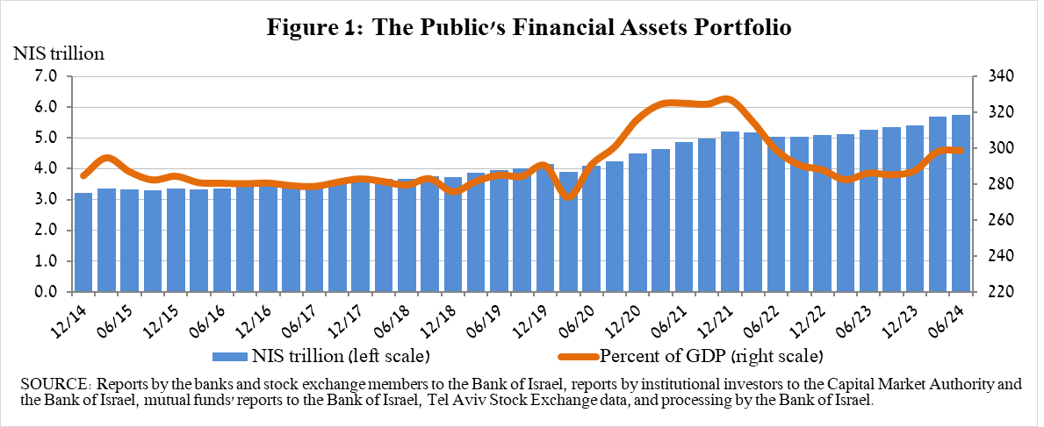

**2. Analysis of the changes in the overall portfolio**

Over the course of the second quarter, there were increases in the balances of the public’s holdings in most components of the portfolio, with the exception of equities in Israel (-8.5 percent) and corporate bonds (-2.1 percent). The increases in the balance of investments abroad (6.1 percent), and in the balance of government bonds and *Makam* (3.5 percent) were notable.

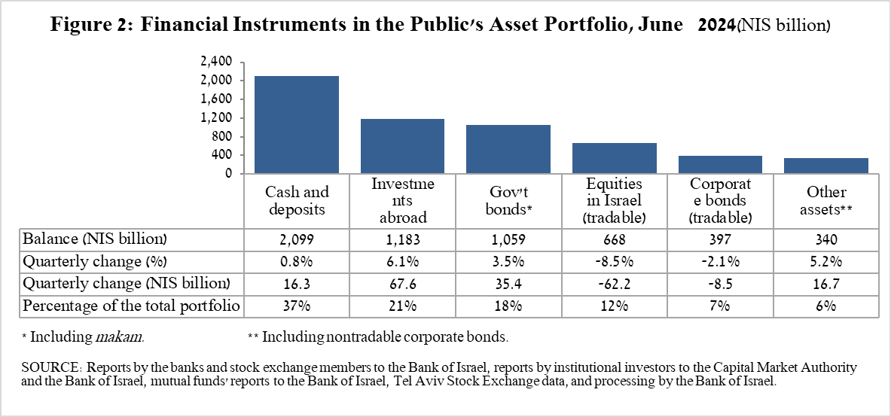

* The balance of **equities in Israel** declined by about NIS 62.2 billion (8.5 percent), mainly in view of price declines on the equity indices, which were partly offset by net investments (estimated at about NIS 1.9 billion).
* The balance of **tradable corporate bonds in Israel** declined by about NIS 8.5 billion, to about NIS 397 billion at the end of the quarter, due to price declines and net realizations.
* The balance of **government bonds** (tradable and nontradable) and ***Makam*** increased during the quarter by about NIS 35.4 billion (3.5 percent) to about NIS 1.06 trillion at the end of the quarter. The increase was mainly due to the increase in tradable government bonds (about NIS 22 billion), and an increase in *Makam* (about NIS 15 billion).
* The balance of **cash and deposits** increased during the second quarter by about NIS 16.3 billion (0.8 percent) to about NIS 2.1 trillion, which is about 36 percent of the total portfolio.

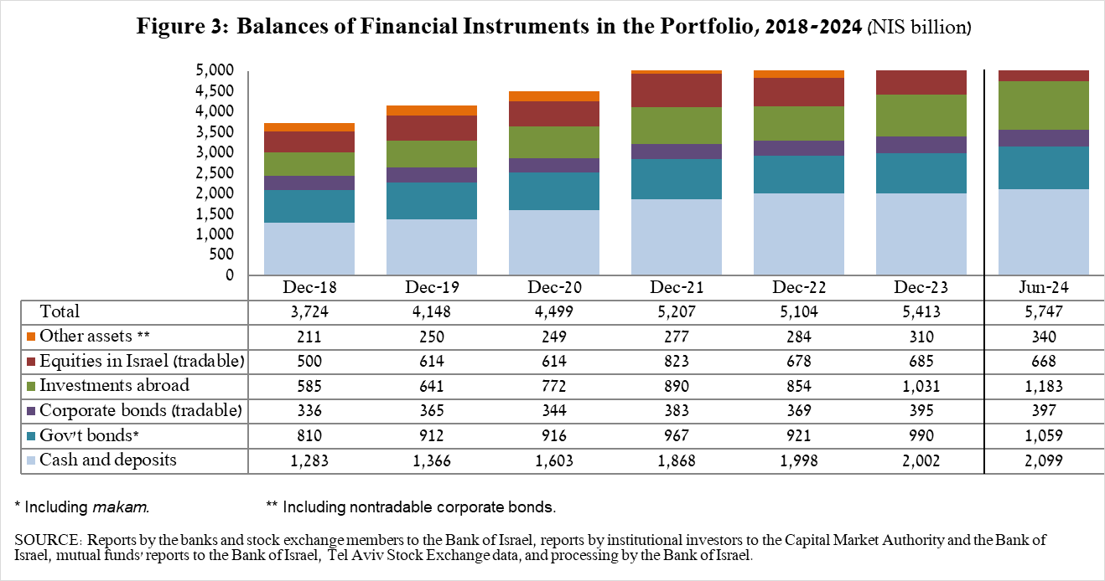

The balance of investments abroad increased by approximately NIS 67.6 billion (6.1 percent) during the quarter, to NIS 1.18 trillion at the end of the quarter, constituting approximately20.6 percent of the total asset portfolio. The development in the balance of investments abroad was mainly due to the following components:

* The balance of **equities held abroad** increased by approximately NIS 40 billion (6.4 percent), to about NIS 669.7 billion. This was mainly the result of price increases and net investments, (estimated to be about NIS 11.8 billion).
* The balance of **tradable (corporate and government) bonds abroad** increased by approximately NIS 15 billion (5.9 percent) during the quarter, to about NIS 269.6 billion. This increase was mainly due to net investments totaling about NIS 10.6 billion.
* The balance of **investment funds** increased by about NIS 12 billion (5.4 percent) to about NIS 242.9 billion at the end of the quarter.

As a result of the developments during the quarter, there was an increase of about 1.1 percentage points (from 26.6 percent to 27.7 percent) in the share of foreign currency assets, and an increase of about 1 percentage point (from 19.6 percent to 20.6 percent) in the share of foreign assets.

# 3. The portfolio managed by institutional investors[1]

* **The balance of assets managed by all institutional investors** increased in the second quarter by about NIS 41 billion (1.6 percent), to about NIS 2.66 trillion (approximately 46 percent of the public’s total financial assets portfolio). The increase in the balance was reflected in all institutional investors, except for the veteran pension funds and profit-sharing insurance policies. The increase in the balance of the managed portfolio during the quarter was mainly due to price increases in the global equity markets, and was reflected in the following components: investment funds abroad—an increase of about NIS 12 billion (5.4 percent), mainly in hedge funds; ETFs abroad that track equity indices—an increase of about NIS 11 billion (5.8 percent), mainly in view of price increases; government bonds and *Makam—*an increase of about NIS 9.7 billion (1.2 percent); equities abroad—an increase of about NIS 8 billion (5 percent), mainly in view of price increases; equities in Israel—a decline of about NIS 23.2 billion (9.6 percent), mainly in view of price declines and net realizations; corporate bonds in Israel—a decline of about NIS 10.3 billion (5.4 percent), mainly in view of price declines and net redemptions.
* **Exposure of the portfolio managed by institutional investors[2] to foreign assets and to foreign currency**

In the second quarter of 2024, the rate of institutional investors’ exposure to assets abroad increased by about 2.3 percentage points, to approximately 47 percent of total assets. This was a result of an increase in the balance of exposure to foreign assets (4.4 percent) and a decline in the balance of institutional investors’ total assets (0.7 percent) in dollar terms.

The increase in the balance of exposure to foreign assets (about $13 billion) was mainly due to an increase in exposure through futures contracts and options on foreign equity indices (about $7.7 billion), and in the balance of equities abroad (about $5.6 billion).

**Exposure to foreign currency** -

During the second quarter of 2024, institutional investors made net purchases foreign currency assets totaling about $3.2 billion—purchases of about $4.9 billion in assets denominated in and indexed to foreign currency (mainly ETFs and foreign equities traded in Israel, and equities and investment funds abroad), and parallel net sales of foreign currency via derivative financial instruments totaling about $1.7 billion, meaning an increase in futures transactions to sell foreign currency.

In this quarter, there was an increase in the rate of institutional investors’ exposure to foreign currency (including NIS/forex derivatives) of about 1 percentage point to a level of about 23.6 percent.

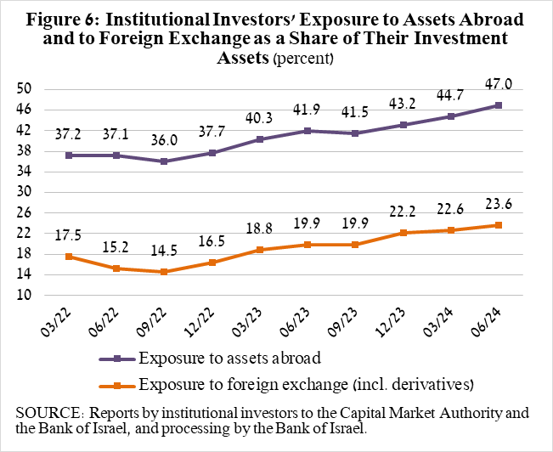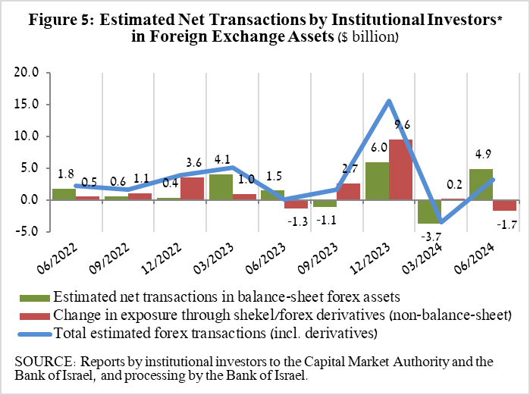

# 4. The portfolio managed by mutual funds

The value of the portfolio managed by Israeli mutual funds increased in the second quarter by approximately NIS 22.5 billion (4.5 percent), to about NIS 518.2 billion at the end of the quarter, constituting about 9 percent of the public’s asset portfolio.

The increase in the second quarter was mainly due to net new investment in the funds totaling about NIS 17.8 billion and from price increases. Most of the new investment was in shekel money market funds, totaling approximately NIS 9.9 billion, and in funds specializing in equities abroad, totaling about NIS 6.6 billion.

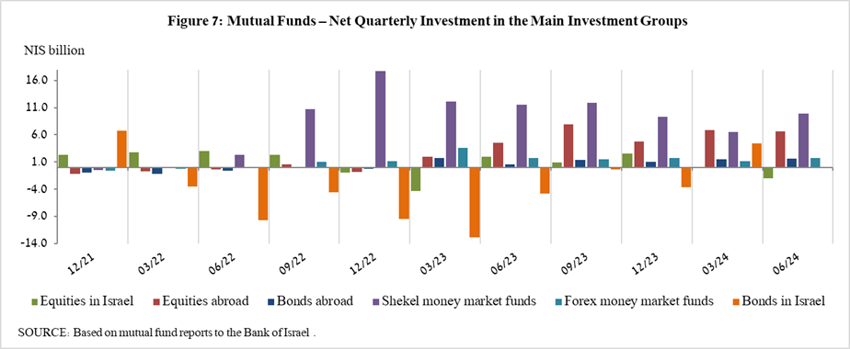

**Further information and details:**

Long-term tables on the asset portfolio are available here.

Long-term tables on institutional investors’ exposure to foreign exchange and to foreign assets are available here.

Long-term tables on mutual funds are available here.

1. Excluding mutual funds.
2. Estimates of members’ exposure (rather than exposure of the institutional investors themselves) to various risks in the portfolio managed for them by the institutional investors (excluding insurance policies with a guaranteed yield, where the risk is taken on by the institutional investors). For additional details on definitions, terms, and explanations, see “Measuring the Exposures of Institutional Investors to Foreign Currency and to Foreign Assets” in the Bank of Israel’s *Statistical Bulletin* for 2016.